Name and Recode Variables Before You Export from Qualtrics
Version 2.0 draft, September 2026.
Companion to Chapter 7 (Export Survey Data) of The Quantitative Playbook for R
Required: do this before anyone exports the data
When data collection ends, your team will export the survey from Qualtrics into R (quantitative track) or NVivo (qualitative track). Team members will use this shared team dataset for their individual reports using their own copy of this original team file. If two copies have different variable names or different numbers behind the same answer, the team cannot merge the dataset in R with the dataset in NVivo to analyze results for any mixed-methods research questions. There is no fixing this afterwards.

Go: Meet as a Team to Follow These Steps
Your team should use your team meeting or team time during lecture to FOLLOW THESE STEPS TOGETHER before anyone exports/downloads your Qualtrics survey data.
Name every variable in your Qualtrics Survey → Recode every answer choice so there are numerical values assigned to ALL of the response options → Check with the team codebook → Publish Your Qualtrics Survey again → Export your survey questions (.docx version with (Chapter 7).
Deadline: This should happen during team time in lecture or during your team meeting time in the last week before leaving for Fall break.

Caution: what is safe to change after data collection has started
Safe: renaming a variable (the export tag) and recoding values. Qualtrics applies both to every response already collected, at export time.
Not safe: adding, deleting, or rewording answer choices, or moving questions between blocks. Those change what respondents saw, so responses before and after the change are not comparable. If you must, write down the date and tell your instructor.

1. Name your variables
In Qualtrics, the variable name is the export tag. Click a question, open Recode values in the left panel, and check Question export tags (for a single question, Variable naming) to see and edit it.
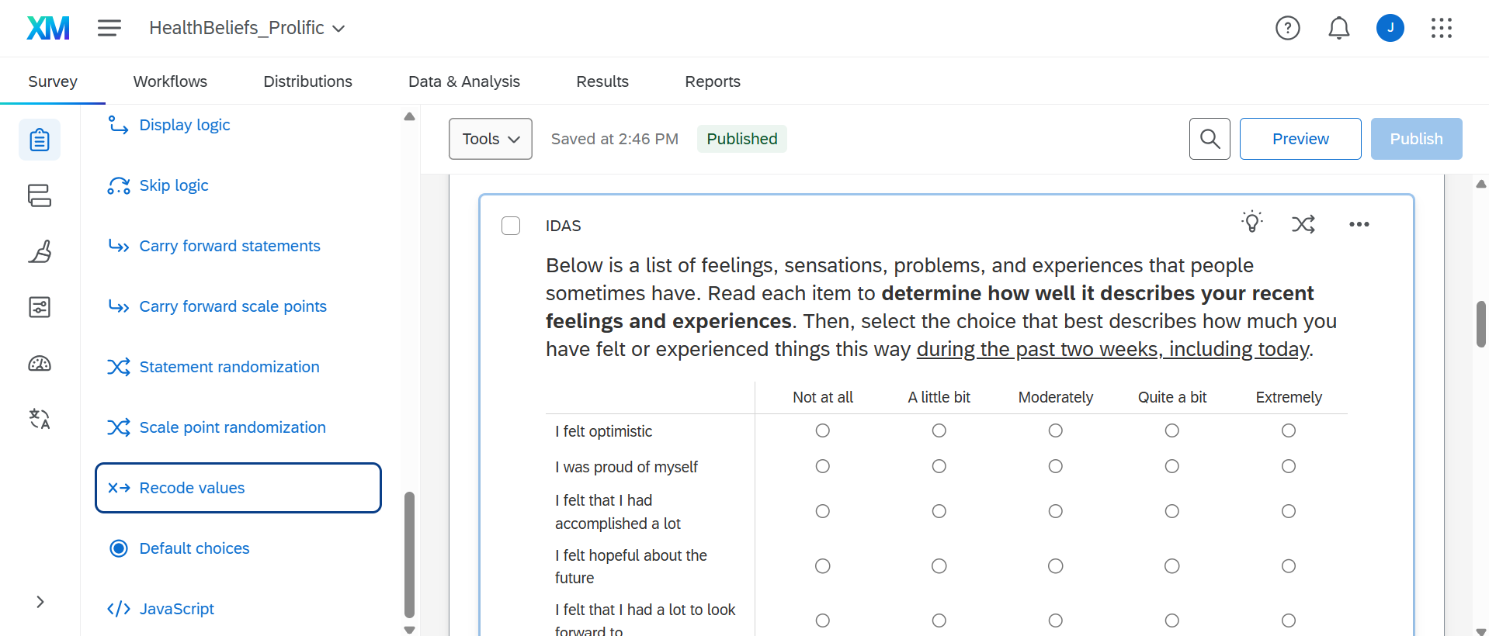

1.1 The rules
Rule | Do this | Not this
ALL CAPS | EFFICACY | selfefficacy
No spaces or symbols (letters, numbers, and _ only) | SELFEFFICACY | SELF EFFICACY, self-efficacy
Short: 14 characters or fewer. Qualtrics cuts long tags off, and R code is easier to read | EFFICACY | EFFECT_EDUCATI (this is what a cut-off tag looks like)
One measure, several items: NAME plus the item number, no underscore | WELLBEING1 … WELLBEING8 | WELLBEING_1, WB1, Wellbeing item 1
One measure with subscales: BIG_SMALL plus the item number | STIGMA_PUB1, STIGMA_SELF1 | PUBSTIG1, SS1
Reverse item: add _R at the end (see 1.3) | STIGMA_PUB4_R | STIGMA_PUB4rev, STIGMA_PUB4 (reversed)
Same measure at two times: _PRE and _POST (or _T1 and _T2) | EFFICACY1_PRE, EFFICACY1_POST | EFFICACY1, EFFICACY1b
Binary (yes/no) variable: add _01CAT, code it 0 and 1, and name it for the answer that gets the 1 | GUNOWNER_01CAT (1 = owns a gun, 0 = does not); PRIORSTUDY_01CAT (1 = took part before) | GUN, OWNERSHIP, GUNOWNER (yes = 1, no = 2)
Categories you will make later in R from a score or by collapsing choices: _#CAT, where # is the number of groups | DISTRESS_4CAT, EDUCATION_3CAT, RACE_5CAT | DISTRESSCATS, EDU3
Open-ended (text) question: add _QUAL | BARRIERS_QUAL | BARRIERS, Q14
A block is not a variable: give blocks a BLOCK_ name | block BLOCK_STIGMA, variable STIGMA_PUB1 | block and variable both called STIGMA

1.2 A measure with subscales: the lab example
The lab dataset measures stigma with two subscales, public stigma (what a person thinks most people believe) and self stigma (how a person would feel about their own mental health problem). Both are in one Qualtrics matrix. Naming them BIG_SMALL# does two jobs at once: in R, you can score the total (STIGMA, all eight items) and each subscale (STIGMA_PUB, STIGMA_SELF) from the same names, and anyone reading your code can see which items belong together.
Export tag | Item | Subscale
STIGMA_PUB1 | Most people would think less of a person who has received treatment for a mental health problem. | public
STIGMA_PUB2 | People with mental health problems are partly to blame for their situation. | public
STIGMA_PUB3 | Most employers would pass over the application of someone with a history of mental illness. | public
STIGMA_PUB4_R | Most people would accept a person with a mental illness as a close friend. | public, reverse
STIGMA_SELF1_R | I would be comfortable telling friends that I was seeing a therapist. | self, reverse
STIGMA_SELF2 | I would feel ashamed if I needed treatment for a mental health problem. | self
STIGMA_SELF3 | Seeking help for a mental health problem would make me feel like I could not handle my own problems. | self
STIGMA_SELF4_R | If I had a mental health problem, I would feel fine telling my family about it. | self, reverse

All eight items use the same answer choices: Strongly disagree (1), Disagree (2), Neither (3), Agree (4), Strongly agree (5). Higher = more stigma.
[ Screenshot to add: the STIGMA matrix in Qualtrics with Question export tags checked, showing STIGMA_PUB1 to STIGMA_SELF4_R and the values 1 to 5 ]

1.3 Reverse items: name them here, reverse them in R
Important: do not flip the numbers in Qualtrics
A reverse item is worded in the opposite direction from the rest of its scale. Agreeing with "Most people would accept a person with a mental illness as a close friend" means less stigma, while agreeing with every other item means more.
In Qualtrics: add _R to the export tag, and leave the values exactly as they are for the other items (Strongly disagree = 1 … Strongly agree = 5).
In R: reverse the _R items with 6 - x (for a 1-to-5 scale) before you average. Creating Composites (Chapter 11) shows this with scoreItems(), where a minus sign in front of the item name does the reversing.
Why not in Qualtrics? If you flip the numbers in Qualtrics and the code in R reverses _R items, the item gets flipped twice and ends up backwards, and nothing warns you. Keeping the raw export in one direction means the reversal is visible in your code, where a reader (and a grader) can check it.

1.4 A single scale with many items: the K10
The Kessler Psychological Distress Scale (K10) has ten items, one construct, and no subscales, so the tags are DISTRESS1 to DISTRESS10. The answer choices are None of the time (1), A little of the time (2), Some of the time (3), Most of the time (4), All of the time (5). The K10 is scored by adding the ten items (10 to 50; under 20 is likely well, 20 to 24 mild, 25 to 29 moderate, 30 and over severe distress). The playbook shows both the sum and the mean in Chapter 11.
The K10 comes with published cut-off scores (Andrews & Slade, 2001), which the Victorian Population Health Survey (2001) and most later surveys use. In R (Chapter 10) you will cut K10_TOTAL into DISTRESS_4CAT (the four bands below) and DISTRESS_01CAT (1 = 20 or above, likely to have a disorder; 0 = 19 or below, likely well). These are screening bands, not diagnoses.
K10 total | Band | DISTRESS_4CAT | DISTRESS_01CAT
10 to 19 | likely to be well | Well | 0
20 to 24 | likely to have a mild disorder | Mild | 1
25 to 29 | likely to have a moderate disorder | Moderate | 1
30 to 50 | likely to have a severe disorder | Severe | 1

Export tag | In the past 4 weeks, about how often did you feel …
DISTRESS1 | tired out for no good reason?
DISTRESS2 | nervous?
DISTRESS3 | so nervous that nothing could calm you down?
DISTRESS4 | hopeless?
DISTRESS5 | restless or fidgety?
DISTRESS6 | so restless you could not sit still?
DISTRESS7 | depressed?
DISTRESS8 | that everything is an effort?
DISTRESS9 | so sad that nothing could cheer you up?
DISTRESS10 | worthless?

References for the K10
Andrews, G., & Slade, T. (2001). Interpreting scores on the Kessler Psychological Distress Scale (K10). Australian and New Zealand Journal of Public Health, 25(6), 494–497. https://doi.org/10.1111/j.1467-842X.2001.tb00310.x
Kessler, R. C., Andrews, G., Colpe, L. J., Hiripi, E., Mroczek, D. K., Normand, S.-L. T., Walters, E. E., & Zaslavsky, A. M. (2002). Short screening scales to monitor population prevalences and trends in non-specific psychological distress. Psychological Medicine, 32(6), 959–976. https://doi.org/10.1017/S0033291702006074
Kessler, R. C., Barker, P. R., Colpe, L. J., Epstein, J. F., Gfroerer, J. C., Hiripi, E., Howes, M. J., Normand, S.-L. T., Manderscheid, R. W., Walters, E. E., & Zaslavsky, A. M. (2003). Screening for serious mental illness in the general population. Archives of General Psychiatry, 60(2), 184–189. https://doi.org/10.1001/archpsyc.60.2.184
Victorian Department of Human Services. (2001). Victorian Population Health Survey 2001: Selected findings. Melbourne: Department of Human Services.

1.5 Shared class variables
Every team's survey has these variables, with exactly these names and values, so that the class can be analyzed together. ResponseId is created by Qualtrics and is the only name that is not all caps.
Variable | Question | Values
ResponseId | (automatic) | Qualtrics' ID for each response. Never rename or delete it.
PASSWORD | The code the respondent made up (pre/post teams only) | Text. Must have the same export tag in both surveys, or the surveys cannot be linked.
CONSENT | Consent statement | 1 = consents and is eligible; 0 = does not
AGE | What is your age? | Whole number. Turn on Qualtrics content validation (number, 18 to 99) so nobody can type "twenty".
GENDER | Which term best describes your current gender identity? | 0 = Girl or woman; 1 = Boy or man; 2 = Nonbinary, genderfluid, or genderqueer; 3 = Not sure or questioning; -50 = Don't know what this means; -99 = Decline
RACE | What is your racial/ethnic identity? (single choice) | 1 = American Indian or Alaska Native; 2 = Asian; 3 = Black or African American; 4 = Hispanic or Latine; 5 = Middle Eastern or North African; 6 = Native Hawaiian or Pacific Islander; 7 = White; -99 = Prefer not to say
SOCIALSTATUS | The ladder | 1 (bottom) to 10 (top)
HEALTHSTATUS | Would you say your health in general is … | 1 = Poor; 2 = Fair; 3 = Good; 4 = Very good; 5 = Excellent
IDAS_WELL | I felt hopeful about the future | 1 = Not at all; 2 = A little bit; 3 = Moderately; 4 = Quite a bit; 5 = Extremely
IDAS_ANX | I found myself worrying all the time | 1 to 5, as above

Caution: RACE must be single choice
If the race question allows more than one answer (checkboxes), Qualtrics exports it as several columns, or as one cell such as 2,7, plus a separate text column for "Other". That cannot be used as one numeric variable, and the White vs. People of Color comparison in the playbook will not work. Make the question single answer (radio buttons), and drop the "Other" text box or leave it as its own _QUAL variable.

2. Recode the values
Recoding assigns a number to each answer choice. Click the question, open Recode values, and check Recode values. Qualtrics exports the numbers; the words are only for the respondent.
Kind of question | Values | Example
Consent | 1 = yes, 0 = no | CONSENT (a shared class variable, so it keeps its name)
Yes/no, have/do not have | 1 = yes (the thing the variable is named for), 0 = no | GUNOWNER_01CAT: 1 = owns, 0 = does not
"None", "never", "I do not have one" | 0 | MEALPLAN: 0 = no meal plan, then 1, 2, 3 for the plans
Agreement, frequency, or other ordered scale | 1 for the lowest step up to the highest step, in order | Strongly disagree (1) … Strongly agree (5)
Categories with no order (majors, states, plans) | 1, 2, 3 … in the order shown; the numbers are labels only | STATE
Prefer not to say / Decline | -99 | every question that offers it
Don't know / Not sure | -50 | every question that offers it

In R, -99 and -50 both become missing (NA) in the first cleaning step (Chapter 8), so they never get averaged into a score by mistake.

What each dialog looks like
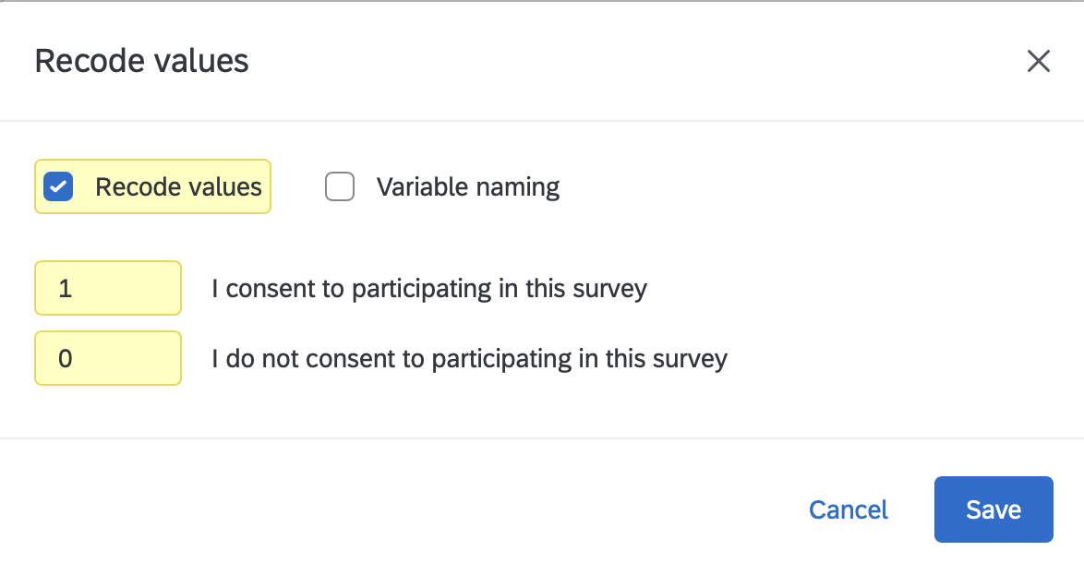
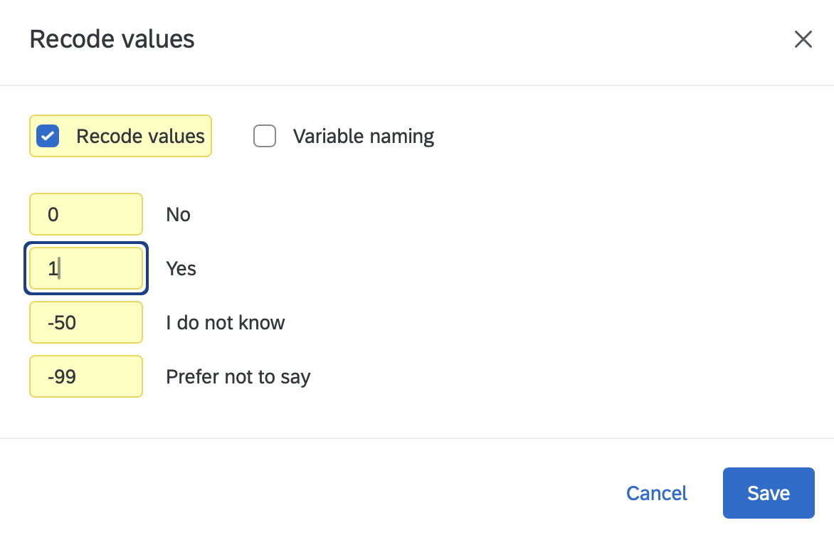
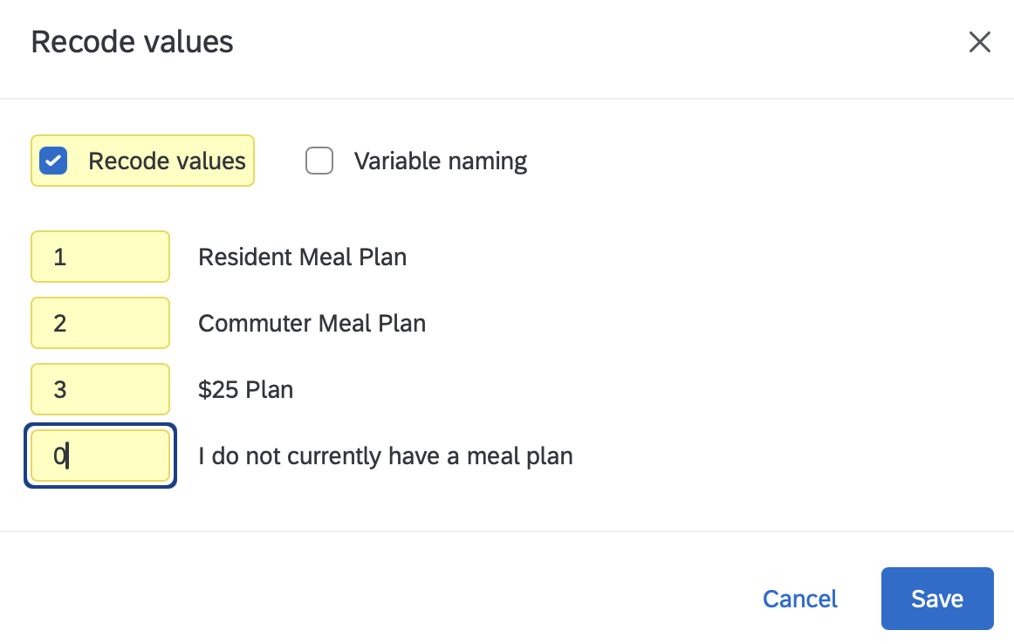
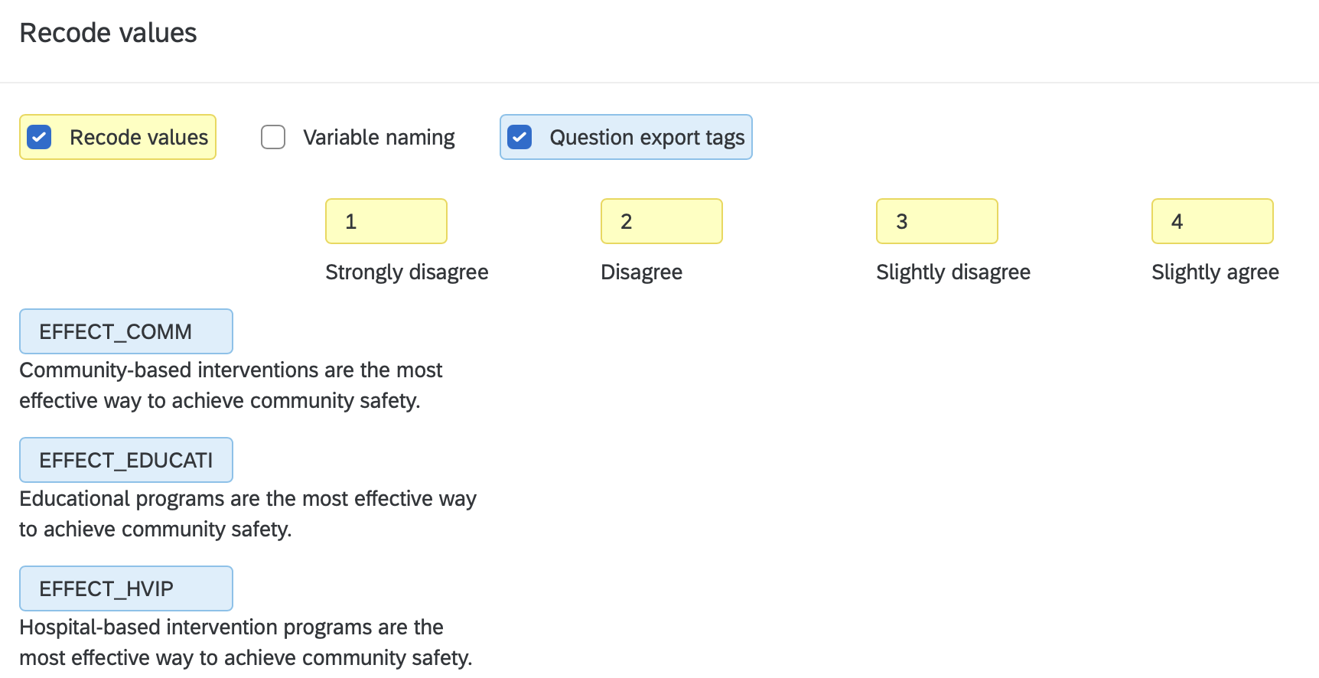
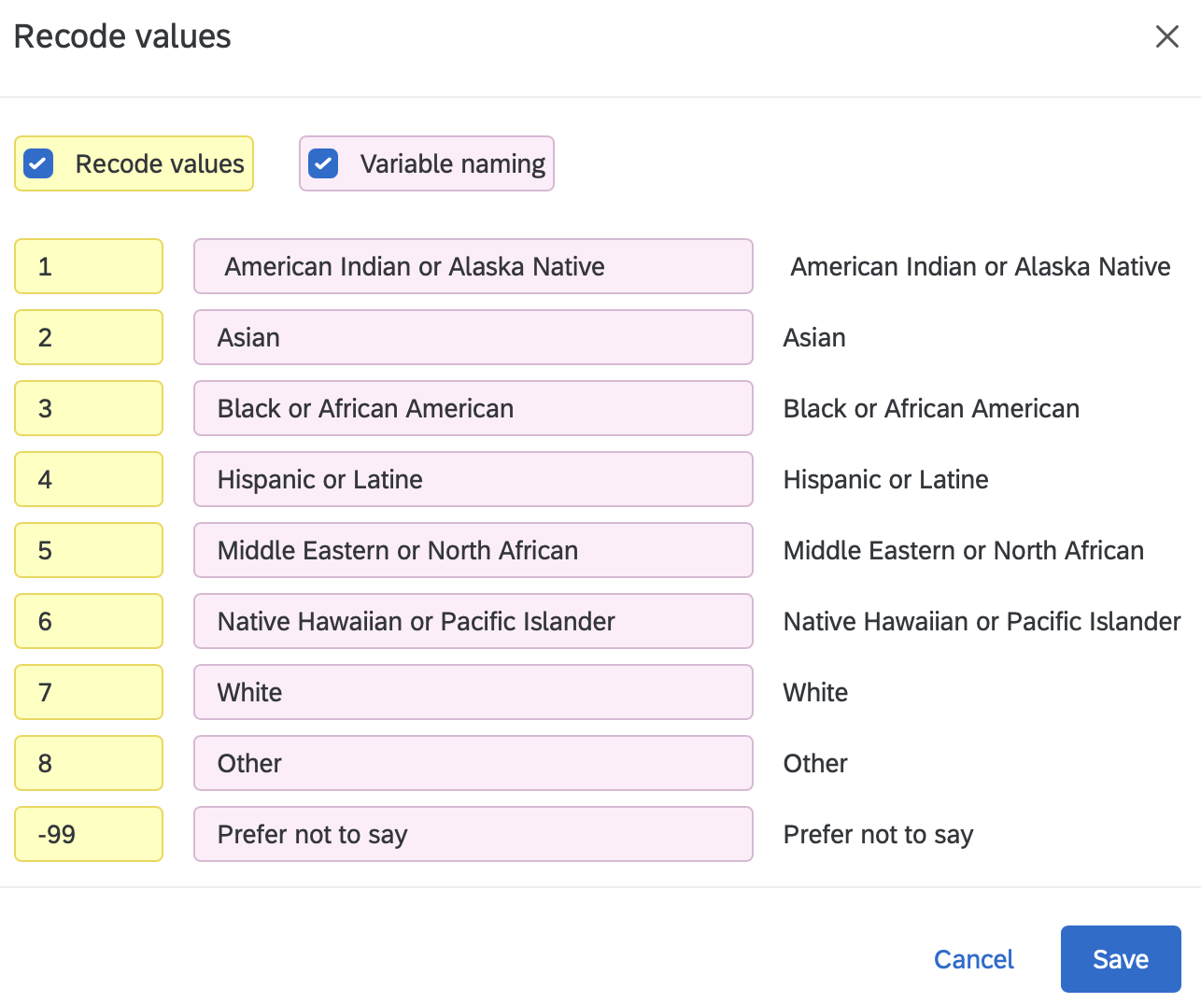
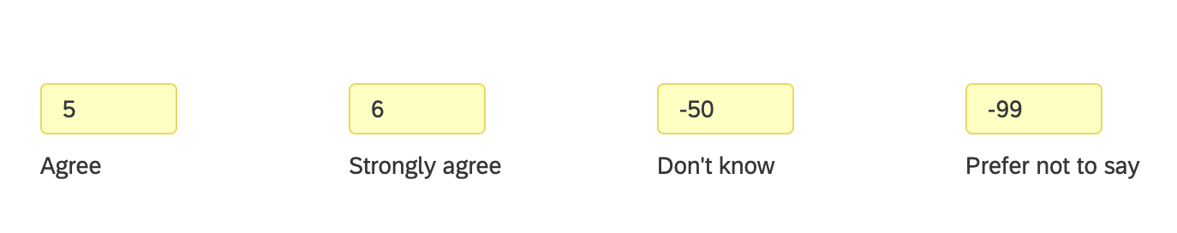

Matrix questions
For a matrix (one instruction, several items in rows), check Question export tags as well as Recode values. Then you name every row and recode the columns in one dialog. The two screenshots below are from other surveys; the first is a single construct (WELLBEING1 to WELLBEING6), the second has subscales (SLEEP_NAP1, SLEEP_TIME1, SLEEP_TIME2, SLEEP_DRINK1, SLEEP_DRINK2).
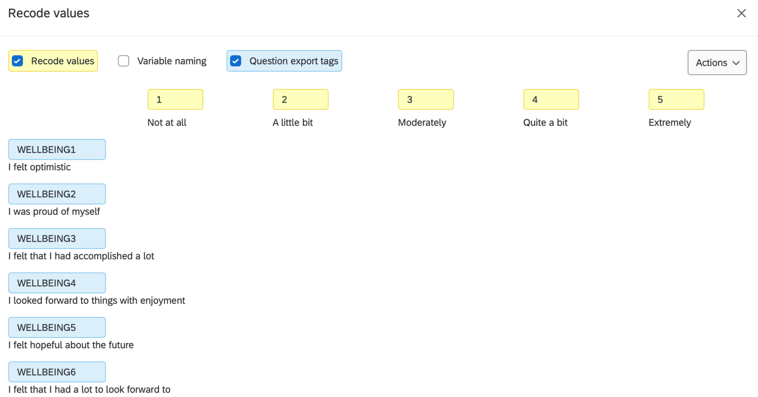
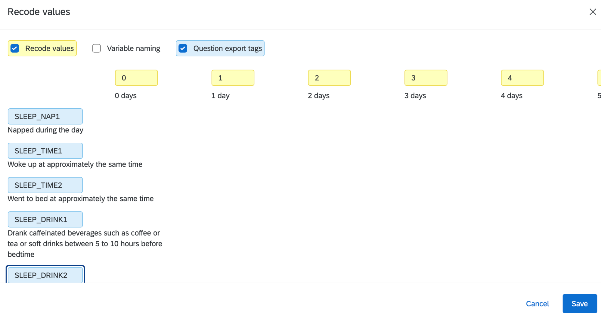
Caution: gaps in the numbers
If a team edits the answer choices, Qualtrics often leaves the codes with a gap, such as 1, 2, 4, 5, and "Agree" quietly becomes 4 instead of 3. Open Recode values on every question and read the numbers in order before you publish.

3. Check with a team codebook
Before you publish, one teammate fills in a codebook, one row per variable, and a second teammate checks every row against Qualtrics. You will paste this table into your Methods section later, and Chapter 8 uses it to check that the exported file matches.
VARIABLE | QUESTION or item text | TYPE | VALUES | SCALE / subscale
STIGMA_PUB4_R | Most people would accept a person with a mental illness as a close friend. | ordered 1–5, reverse | 1 = Strongly disagree … 5 = Strongly agree | STIGMA, public
DISTRESS7 | … about how often did you feel depressed? | ordered 1–5 | 1 = None of the time … 5 = All of the time | K10 (DISTRESS)
GUNOWNER_01CAT | Do you own a gun? | binary | 1 = yes, 0 = no | single item
BARRIERS_QUAL | What would make it hard for you to get help? | open-ended text | (text) | single item

Team checklist: all boxes before Publish
- Every export tag is ALL CAPS, has no spaces, and is 14 characters or fewer.
- Every multi-item measure is NAME1, NAME2 … or BIG_SMALL1, BIG_SMALL2 …
- Every reverse item ends in _R and its values were not flipped in Qualtrics.
- Every binary variable ends in _01CAT, is coded 0/1, and is named for the 1.
- Prefer not to say = -99 and Don't know = -50 everywhere they appear.
- No gaps in any question's codes.
- The shared class variables have the exact names and values in section 1.5.
- Pre/post teams: PASSWORD has the same export tag in both surveys.
- The team codebook is complete and a second person has checked it.
- Click Publish. Recodes are not saved to the live survey until you do.

Now go to Chapter 7, Export Survey Data.

